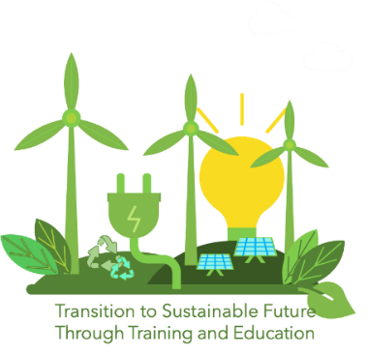
APPLICATION FORM FOR THE COMPETITION
FOR THE BEST DRAWING

Project Title: TRANSITion to Sustainable Future Through Training and Education – TRANSIT
The primary schools and their pupils of ages 7-11 are invited to take part in the competition for the best drawing depicting renewable energy, organized by TRANSIT project. The winner of the competition will receive a present offered by the organiser, while the school of the winner will receive a national trophy and 300 Eur. If you are willing to participate in the competition, please complete and sign this application form and return it to the info@fir.mt email address with attached drawings (as photos or scanned versions) by 19th May 2025.

- General data
Primary school name
Address
E-mail address
Website
Drawing 1 | Author’s name and surname
 | Age
 | Gender
 | Title of drawing
Drawing 2 | Author’s name and surname
 | Age
 | Gender
 | Title of drawing
Drawing 3 | Author’s name and surname
 | Age
 | Gender
 | Title of drawing
Drawing 4 | Author’s name and surname
 | Age
 | Gender
 | Title of drawing
Drawing 5 | Author’s name and surname
 | Age
 | Gender
 | Title of drawing
Drawing 6 | Author’s name and surname
 | Age
 | Gender
 | Title of drawing
* Please, insert rows for each participating drawing.

- Drawings
Attach the drawings. Please, indicate clearly the serial number of each drawing.

- Participant’s statements
Please tick the appropriate boxes
- I certify that all information provided in this application form is correct.
- I agree to take part in the competition for the best drawing.
- I confirm that each participating child-author gave consent to have the drawing published on the TRANSIT project and EU platforms.

_____________________ ______________ __________
Name of Participant Date Signature

