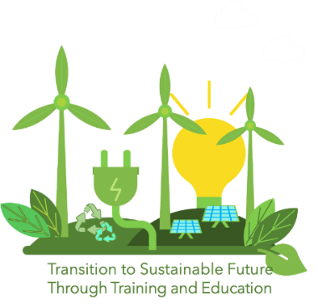
APPLICATION FORM FOR THE COMPETITION
FOR INDUSTRIES AND TRADE ASSOCIATIONS

Project Title: TRANSITion to Sustainable Future Through Training and Education – TRANSIT
Industry and trade associations working in the area of renewable energy, which in the last 12 months acted on the deployment of renewable energy, and/or upskilling employees on the transition to sustainable lifestyle/careers, and/or support the local communities to adopt sustainable practices, are invited to take part in the competition organised by TRANSIT project. If you are willing to participate in the competition, please complete and sign this application form. Maximum number of pages of the application form is 5. Therefore, include only the most important data, figures/tables/photos and references. Please, submit the completed application form in pdf format to the following e-mail address: info@fir.mt

- General data
The name of industry/trade association
Address
E-mail address
Phone number
Web page
Social networks (optional)
Percentage of male and female employees in the industry/trade association

- The summary of other relevant data
Work on deployment of renewable energy (max 200 words) | Explain the work on deployment of RE.
Work on upskilling employees for the transition to sustainable lifestyle/careers (max 100 words) | Explain the work on upskilling employees around the transition to sustainable lifestyle/careers.
Work to support the local communities to adopt sustainable practices (max 100 words) | Explain the work on support the local communities to adopt sustainable practices.
Impact of the achievements of industry/trade association (max 100 words) | Quantify or at least evaluate the impact of the outcomes of industry/trade association for renewable energy deployment and achievements in transition towards renewable energy on end users.
Note: Only data related to the last 12 months are of interest.

- Deployment of RE
Explain the work of the participant on deployment of RE in the last 12 months. Give the most important figures/photos and cite adequate references. No special equation, figure, table or reference formats are required on this application form.

- Upskilling employees around the transition to sustainable lifestyle/careers
If the participant has worked on upskilling employees around the transition to sustainable lifestyle/careers in the last 12 months, this Section would describe such work and its results. Relevant references would be cited.

- Support the local communities to adopt sustainable practices
This Section exists, if the participant has worked to support the local communities to adopt sustainable practices in the last 12 months. The Section should describe such work and its achievements, provide relevant figures/photos and cite references.

- Impact of the achievements
Summarize the impacts of the outcomes of the participant for deployment of RE and achievements in transition towards renewable energy on end users in the last 12 months. Quantify or at least evaluate these impacts. If necessary, enter more Sections than indicated on this application form.

- Conclusions
Emphasize the most important conclusions related to the results of participant’s work for renewable energy deployment and achievements in transition towards renewable energy.

- References
This section encompasses the most important references including the links to web pages with the evidences of the participant’s work.

- Participant’s statements
Please tick the appropriate boxes
- I certify that all information provided in this application form is correct.

- I agree to take part in the competition for the industry/trade associations.

_____________________ ______________ __________
For the participant Date Signature

The national award is TRANSIT trophy. The international award is the trophy and monetary prize of 1000 EUR.

